The following install files are available at O:\

- IMA2_Install.bat
- IMA2_Register.bat
- IMA2_Unregister.bat

You could come across two issues in the files:
- The Install.bat calls the Register.bat from IMA2/System. Notice that the path is now different, and it should be redirected to the main folder where the file is contained.
- Whenever the regsvr32 command is called and it does not work.
You need to appended the c:\windows\system32 path to it…

If there are missing components registered in VisualBasic for DAD, one could see the following errors:

- “I can create an agent by right-clicking on the host computer, but as soon as I give that agent a name, press enter, and then try to click on it and error comes up saying:”

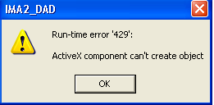

- And, if I do not click on the agent icon once it has been created, but rather, go back and click on the host computer icon, it will let me see the agent icon in the agent list view:
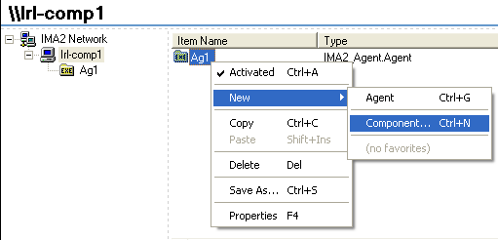

- As soon as I try to click on Component, it gives me the following error:

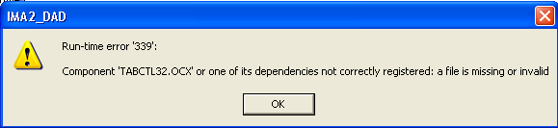

One has to add these files to VB in the DAD Project.

